Dynamic Time Warping Application – Diagnosis of Reactor Systems
Module 6 – Portfolio Milestone

Andrew J. Cunningham
Colorado State University Global Campus
CSC506 – Design and Analysis of Algorithms
Dr. Brian Holbert
25 April 2025

Summary of How We Got to Now
The overall objective of this project is to detect failure criteria of a nuclear reactor by comparing current neutron flux signals with that of a healthy core (Jeong et al., 2024). The following steps have been completed to achieve this objective:
- A signal generation algorithm has been implemented to create sine waves using numpy for given frequencies and amplitudes. This can be used to create a baseline “healthy” core and additional parameters can be added to simulate a “damaged” core.
- Fast Fourier Transform was applied to the resulting data to extract frequency and amplitude data.
- Dynamic Time Warping (DTW) was utilized to form a cost matrix of differences between the characteristics of each signal.
- Backtracking was utilized to pinpoint significant differences along this cost matrix.

Improving Simulated Data
Earlier versions of the input data were simulated to demonstrate that there was a difference in the algorithm output. Those earlier tests are shown in figure 1.

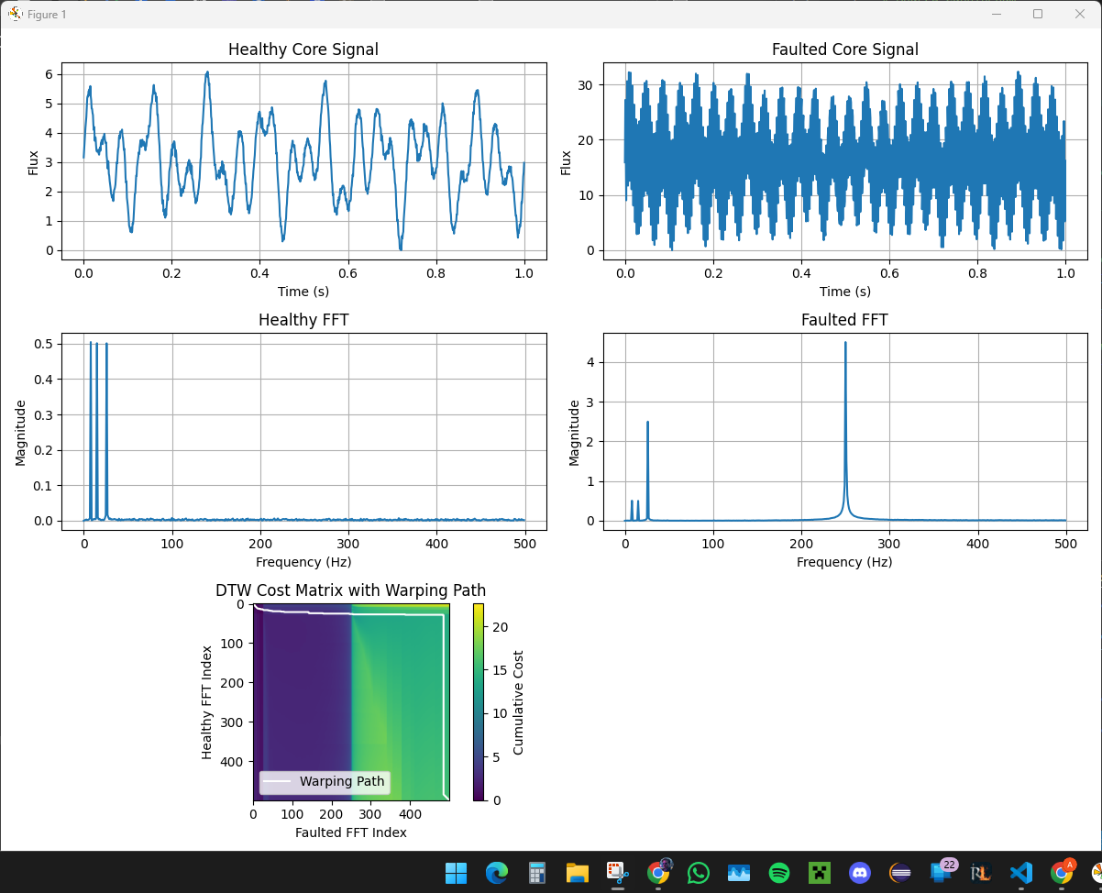
Figure 1. Simple input data to show a large fault at 250Hz.
The final data is going to look slightly different. I added a little bit more noise in the healthy core, adjusted the noise for one base frequency in the faulted core, and reduced the amplitude of the higher frequency that indicates the fault. All I did was introduce a magnitude spike at 26 Hz and a new, smaller spike at 250Hz. Here is the final data I’ll be proceeding with. This allows for smoother operations later on.

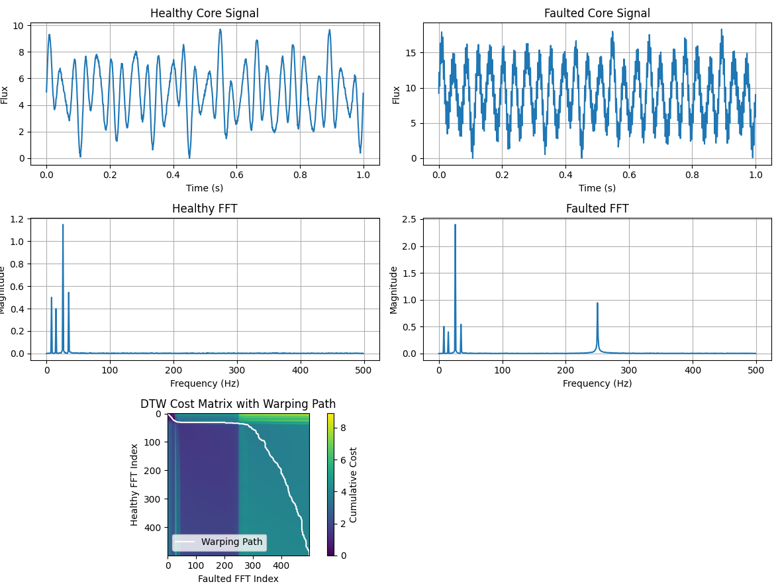
Figure 2. Revised healthy and faulted data
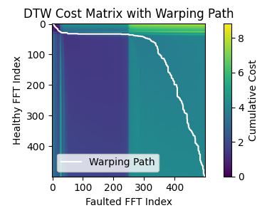
Figure 2a. DTW warping path with 2 signal faults
The warping path contains the answer. A perfectly healthy core would have a diagonal line from top left to bottom right (not shown). Horizontal deflections indicate a new magnitude spike at certain frequencies, here early on then again about half way through the chart. If there was a deletion then it would be reflected in the vertical deflection. As a faulted core wouldn’t remove any signal elements, only add, there are no vertical deflection.

DTW Improvement
The first step towards improving DTW will be to implement upper and lower bounds to prevent significant stretches in cost-analysis that could be introduced by wildly different data (Tavenard). We will do this by implementing a window constraint.
Window selection size is the first challenge to overcome. There are several different options I could select, two of which are “Sakoe-Chiba Band” and “Itakura Parallelogram.” Both of these methods constrain the lower signal to a plus or minus window on the upper signal, but Itakura Parallelogram allows the window to dynamically size, allowing less constraint at the end and more towards the middle. See figure 3 for a visualization.
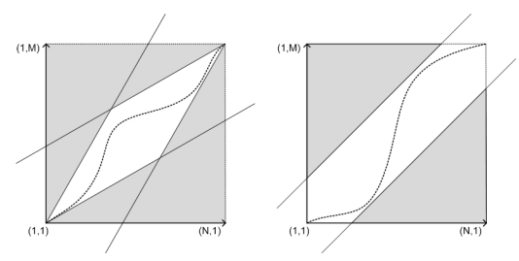
Figure 3. Global path constraints, left: Itakura parallelogram, right: SakoeChiba band. (Senin, 2008)
Sakoe Chiba Band satisfies the requirements of this project as the two sine waves are relatively similar in scope, and tapering the window at each end isn’t necessary. As for the window, 20% was utilized to capture the warping path deviating from the expected.
# selecting Sakoe Chiba Band
n = len(mag_healthy_FFT)
window_percent = 20
window_size = int(n * (window_percent / 100))

def dtw(upper, lower, window=None):
………
for i in range(1, n+1):
j_start = max(1, i - window) if window is not None else 1
j_end = min(m+1, i + window + 1) if window is not None else m + 1
for j in range(j_start, j_end):
………

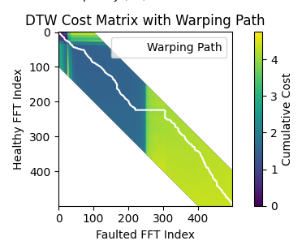
Figure 4. Added a 20% window constraint for DTW
This new constraint greatly enhances the readability and utility of the warping path. We can see a clear horizontal deflection that occurs shortly after 0 on the y axis and another, larger, deflection shortly after 250. We can also clearly see the cumulative cost increases at these two locations.

Final Logic Step – Flag Faults
The final logic that needs to be added to backtracking is adding fault flags to alert the user when cost increases substantially, which could indicate that a fault occurs. This is done in the main program after receiving the optimum path.
# find any faults found in the optimum path
fault_flags = []
threshold = 0.2 # magnitude more than this amount indicates a fault

for (i, j) in optimal_path:
difference = abs(mag_healthy_FFT[i] - mag_faulted_FFT[j])
if difference > threshold:
fault_flags.append((freqs_faulted_FFT[j], difference))

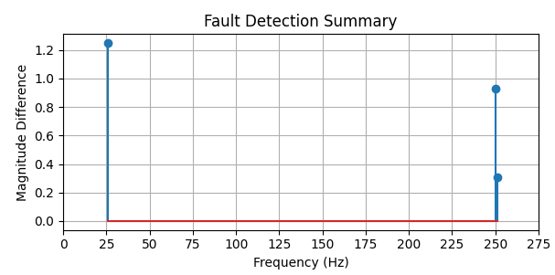
Figure 5. Shown are the magnitude differences and frequencies of the faults
I used a magnitude difference of 0.2 to show that a difference still exists when backtracking analyzes 251 Hz. This is because the algorithm hasn’t had a chance to normalize closer to the baseline. I could have solved this by increasing the difference threshold, but leaving it in illustrates that some interpretation of the data is still required. The final version will have the threshold increased.

Summary of Milestone Requirements
- Analyze the empirical data to determine time and space complexity trends.
Signal generation, FFT, DTW, and backtracking all applied to healthy and faulted signals to generate an accurate list of fault-flags that could be utilized if the input data was absent.
- Compare algorithm performances and identify strengths and weaknesses.
FFT is a fast algorithm to quickly extract frequency data from input signals in O (n log n)
DTW is a slower algorithm at O(n^2), but necessary to create a cost map for warped sequences.
A weakness in these algorithms is they are not good at detecting phase shifts in the data, but that was demonstrated by Inha University, Incheon, in the Republic of Korea (Jeong et al., 2024) and won’t be discussed here.
- Implement any necessary optimizations or improvements to the algorithms.
Amplitudes and noise were adjusted for the healthy core to introduce more variance. The magnitudes of the faults were adjusted to maintain accuracy of a DTW window. Additionally, fault detection was implemented.
- Prepare a report summarizing the analysis and optimizations undertaken.
Included.

Summary
Dynamic Time Warping allows users to compare signals that “look” similar but don’t align in a Euclidian fashion. When combined with FFT results and backtracking, researchers have shown that these algorithms can be employed to detect reactor core faults by comparing magnitude of neutron frequency deviations. When a Sakoe-Chiba window constraint is applied to the data, fault signals can be collected and alert users to failure criteria.

Output
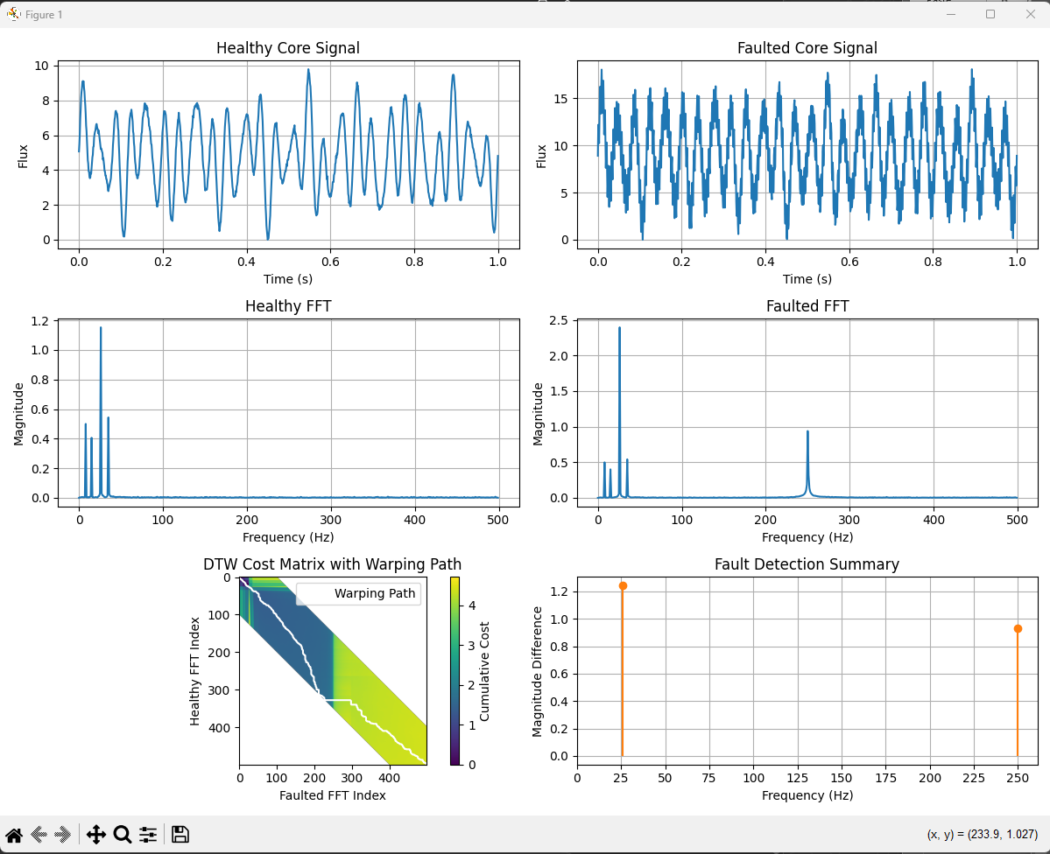

Code
# Main.py

# Andrew Cunningham
# CSC506 Portfolio Project

# Implements DTW and backtracking to predict failure criteria on
# simulated healthy and faulted core ex-core neutron flux

from signal_generation import generate_signal, apply_FFT
from plot_data import plot_healthy_faulted
from dtw import dtw
from backtracking import backtrack
show_plots = True

import numpy as np

# Parameters for a healthy core
freqs = [8, 15, 26, 35] # Hz
amplitudes = [1, 0.8, 2.3, 1.1, 2.1] # healthy amplitudes close to one
sample_rate = 1000 # Hz
duration = 1.0 # Second

# Generate healthy signal
signal_healthy, t_healthy = generate_signal(freqs, amplitudes, sample_rate, duration)

# Parameters for faulted core

freqs_faulted = freqs
freqs_faulted.append(250)
amplitudes_faulted = [1, 0.8, 4.8, 1.1, 2.1, 1.9]

# generate faulted signal
signal_faulted, t_faulted = generate_signal(freqs_faulted, amplitudes_faulted, sample_rate, duration)

# Apply FFT
freqs_healthy_FFT, mag_healthy_FFT = apply_FFT(signal_healthy, sample_rate)
freqs_faulted_FFT, mag_faulted_FFT = apply_FFT(signal_faulted, sample_rate)

# selecting Sakoe Chiba Band
n = len(mag_healthy_FFT)
window_percent = 20
window_size = int(n * (window_percent / 100))

# Apply DTW
dtw_matrix = dtw(mag_healthy_FFT, mag_faulted_FFT, window_size)

# Apply Backtracking
optimal_path = backtrack(dtw_matrix)

# find any faults found in the optimum path
fault_flags = []
threshold = 0.6 # magnitude more than this amount indicates a fault

for (i, j) in optimal_path:
difference = abs(mag_healthy_FFT[i] - mag_faulted_FFT[j])
if difference > threshold:
fault_flags.append((freqs_faulted_FFT[j], difference))

if show_plots:
plot_healthy_faulted(t_healthy, signal_healthy, freqs_healthy_FFT, mag_healthy_FFT,
t_faulted, signal_faulted, freqs_faulted_FFT, mag_faulted_FFT,
dtw_matrix, optimal_path, fault_flags)

# signal_generation.py

# Andrew Cunningham
# CSC506 Portfolio Milestone

# Generate sinusoidal functions to simulate nuclear reactor core ex-core neutron flux
# Implements FFT to analyze the signal data

import numpy as np

def generate_signal(freqs, amplitudes, rate, duration, noise = 0.1):
'''generates a simple sine wave that's translated to be above the horizontal axis
returns the signal and time matricies'''

# generate the baseline signal
t = np.linspace(0, duration, int(rate * duration))
signal = sum(a * np.sin(2 * np.pi * f * t) for f, a in zip(freqs, amplitudes))

# add noise
noise = np.random.normal(0, noise, len(t))
signal += noise

# shift the signal so that there is no negative flux
signal -= np.min(signal)

return signal, t

def apply_FFT(signals, sample_rate):
'''applies FFT to signal and sample_rate
returns frequency and magnitude data'''
# Apply FFT to healthy
signals = signals - np.mean(signals)
fft_result = np.fft.fft(signals)
magnitude = np.abs(fft_result) / len(signals) # Normalize
freqs = np.fft.fftfreq(len(signals), d=1/sample_rate)
# Take only positive frequencies
half_n = len(signals) // 2
freqs = freqs[:half_n]
# also eliminate the spike at 0
magnitude = magnitude[:half_n]

return freqs, magnitude

# dtw.py

# Andrew Cunningham
# CSC506 Portfolio Project

# implements Dynamic Time Warping between two input vectors.

import numpy as np

def dtw(upper, lower, window=None):
'''implements DTW between upper: List[int] and lower: List[int]
Returns dtw_matrix(n x m)'''
n, m = len(upper), len(lower)
dtw_matrix = np.zeros((n+1, m+1))
for i in range(n+1):
for j in range(m+1):
dtw_matrix[i, j] = np.inf
dtw_matrix[0, 0] = 0

for i in range(1, n+1):
j_start = max(1, i - window) if window is not None else 1
j_end = min(m+1, i + window + 1) if window is not None else m + 1
for j in range(j_start, j_end):
cost = abs(upper[i-1] - lower[j-1])
last_min = np.min([dtw_matrix[i-1, j], dtw_matrix[i, j-1], dtw_matrix[i-1, j-1]])
dtw_matrix[i, j] = cost + last_min

return dtw_matrix

# backtracking.py

# Andrew Cunningham
# CSC506 Portfolio Project

# implements backtracking

def backtrack(dtw_matrix):
# get the length of each array
i, j = dtw_matrix.shape[0] - 1, dtw_matrix.shape[1] - 1
path = []

# backtrack, starting at the bottom left, across the matrix diagonal
while i > 0 and j > 0:
# save the next diagonal step
path.append((i-1, j-1))

# evaluate either diagronal, up, or left
diag = dtw_matrix[i-1, j-1]
up = dtw_matrix[i-1, j]
left = dtw_matrix[i, j-1]

# move to the neighbor with the lowest cost
if diag <= up and diag <= left:
i = i-1
j = j-1
elif up < left:
i = i-1
else:
j = j-1

path.reverse()
return path

# plot_data.py

# Andrew Cunningham
# CSC506 Portfolio Project

# contains all of the plotting functions to visualize data

import matplotlib.pyplot as plt
import numpy as np

def plot_healthy_faulted(t_healthy, signal_healthy, freqs_healthy_FFT, mag_healthy_FFT,
t_faulted, signal_faulted, freqs_faulted_FFT, mag_faulted_FFT,
dtw_matrix, optimal_path, fault_flags):
# Plot in 2x3 grid:
# Healthy (top left), Healthy FFT (middle left), DTW Heatmap (bottom left)
# Faulted (top right), Faulted FFT (bottom right), optim

plt.figure(figsize=(12, 9))

# Top left - Healthy signal
plt.subplot(3, 2, 1)
plt.plot(t_healthy, signal_healthy)
plt.title("Healthy Core Signal")
plt.xlabel("Time (s)")
plt.ylabel("Flux")
plt.grid(True)

# Middle left - Healthy FFT
plt.subplot(3, 2, 3)
plt.plot(freqs_healthy_FFT, mag_healthy_FFT)
plt.title("Healthy FFT")
plt.xlabel("Frequency (Hz)")
plt.ylabel("Magnitude")
plt.grid(True)

# Bottom left - DTW Heatmap with Optimal Path
plt.subplot(3, 2, 5)
plt.imshow(dtw_matrix[1:, 1:])
i_vals, j_vals = zip(*optimal_path)
plt.plot(j_vals, i_vals, color='white', linewidth=1.5, label='Warping Path')
plt.colorbar(label='Cumulative Cost')
plt.title("DTW Cost Matrix with Warping Path")
plt.xlabel("Faulted FFT Index")
plt.ylabel("Healthy FFT Index")
plt.legend()

# Top right - Faulted signal
plt.subplot(3, 2, 2)
plt.plot(t_faulted, signal_faulted)
plt.title("Faulted Core Signal")
plt.xlabel("Time (s)")
plt.ylabel("Flux")
plt.grid(True)

# Bottom right - Faulted FFT
plt.subplot(3, 2, 4)
plt.plot(freqs_faulted_FFT, mag_faulted_FFT)
plt.title("Faulted FFT")
plt.xlabel("Frequency (Hz)")
plt.ylabel("Magnitude")
plt.grid(True)

plt.subplot(3, 2, 6)
fault_freqs, fault_magnitudes = zip(*fault_flags) # Unpack into two separate lists
plt.stem(fault_freqs, fault_magnitudes, basefmt=" ", linefmt="C1-", markerfmt="C1o")
plt.xticks(np.arange(0, max(fault_freqs)+25,25))
plt.xlabel("Frequency (Hz)")
plt.ylabel("Magnitude Difference")
plt.grid(True)
plt.title("Fault Detection Summary")

plt.tight_layout()
plt.show()

References
Jeong, H., Kim, J., Jung, D., & Kwon, J. (2024, December 9). Deep-Learning and Dynamic Time Warping-Based Approaches for the Diagnosis of Reactor Systems. Sensors Journal. https://www.mdpi.com/1424-8220/24/23/7865

Tavenard, R. (n.d.). An introduction to Dynamic Time Warping. Rtavenar.github.io. https://rtavenar.github.io/blog/dtw.html

Senin, P. (2008, December). Dynamic Time Warping Algorithm Review. Information and Computer Science Department . https://csdl.ics.hawaii.edu/techreports/2008/08-04/08-04.pdf

